**Hospital Management System**

* **Design schema:**

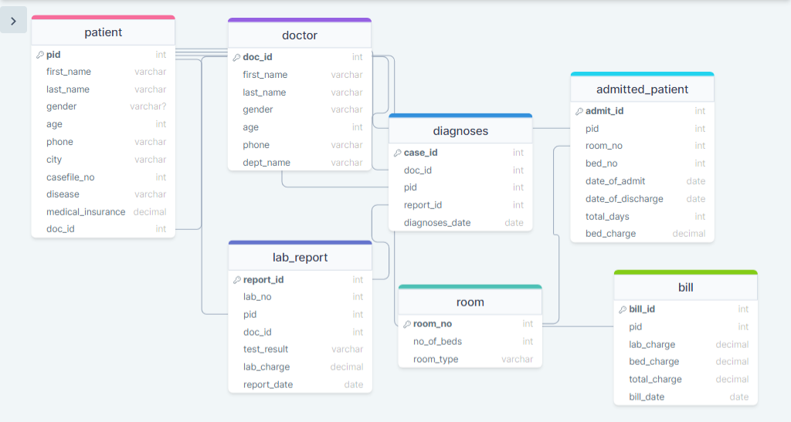

* **Normalization:**

This schema is in Third Normal Form (3NF), as there are no transitive dependencies, and each non-prime attribute is fully functionally dependent on the primary key. I have use third Normal Form (3NF) to reduce data redundancy and maintain data integrity.